**ASSIGNMENT-1**

**AMAZON LINUX (1st instance )**

**STEP-1**

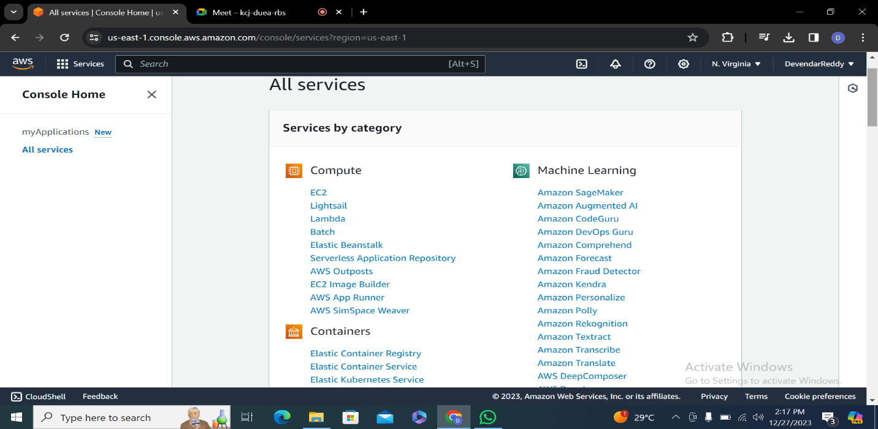

**STEP-2 click on instances**

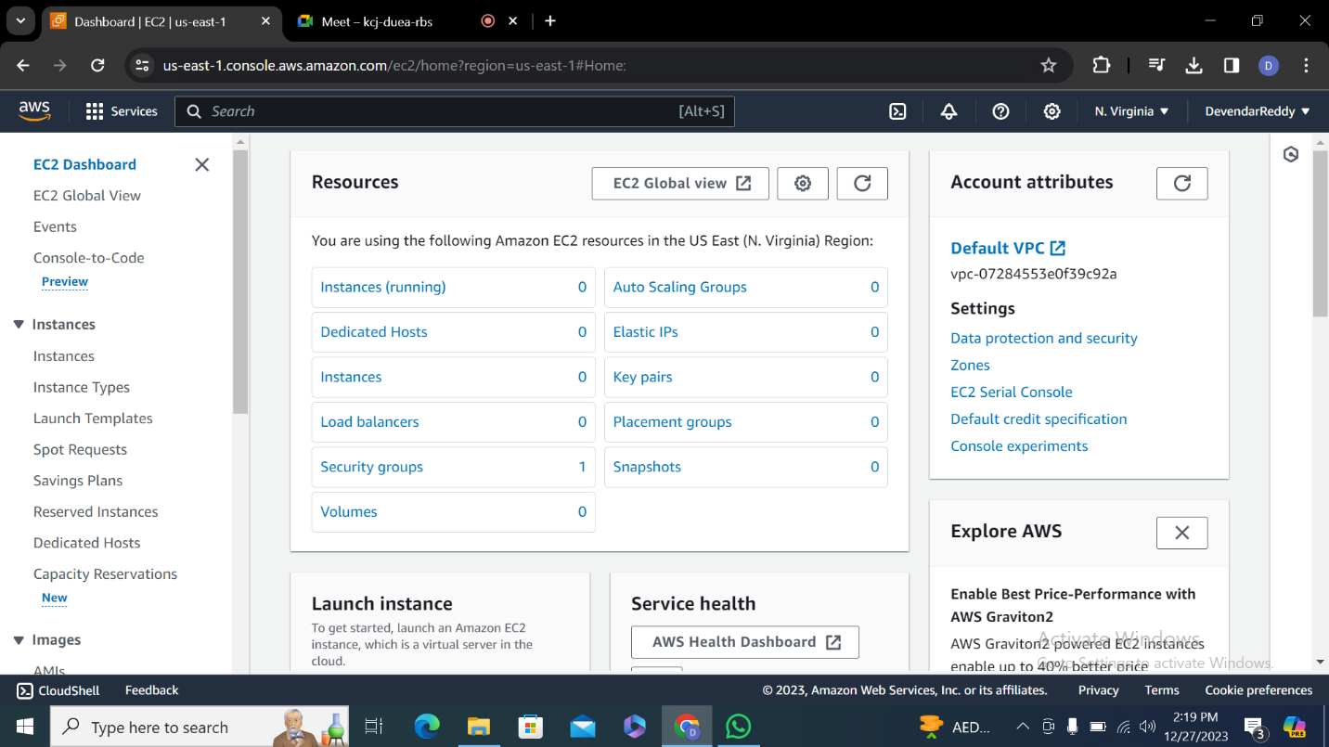

**Step-3 enter server name**

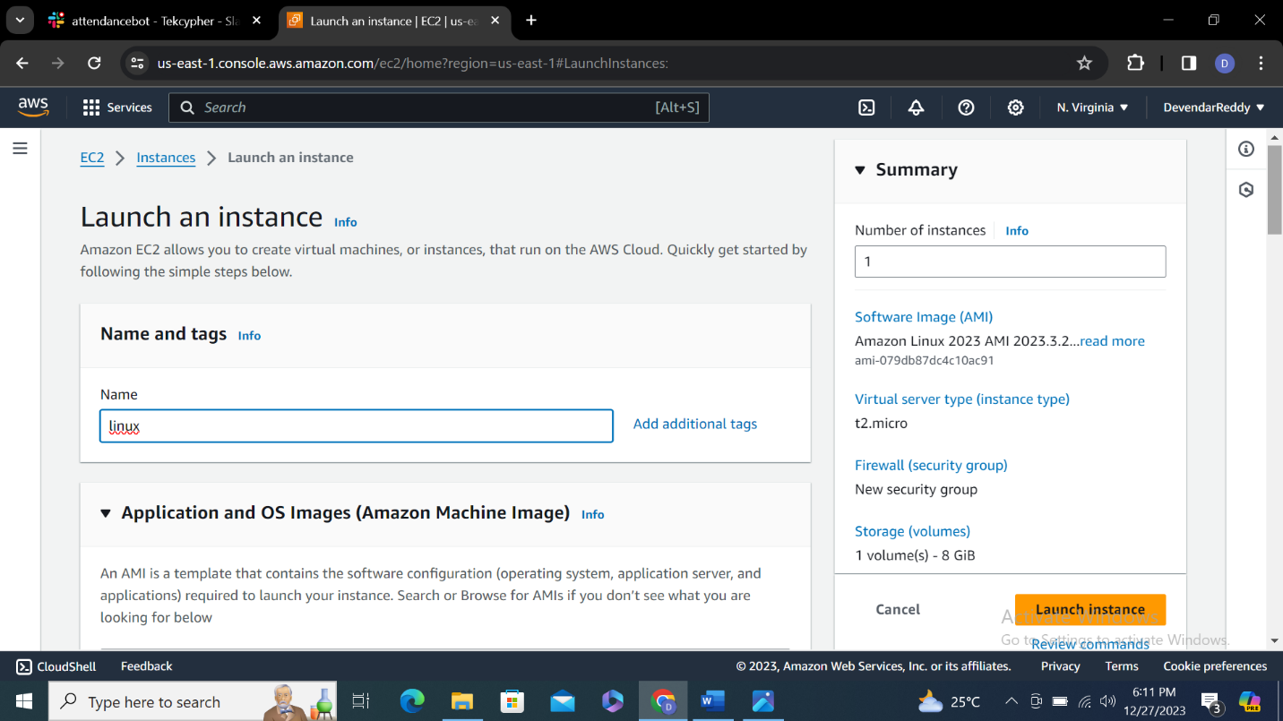

**Step-4 select aws linux in quick start ami**

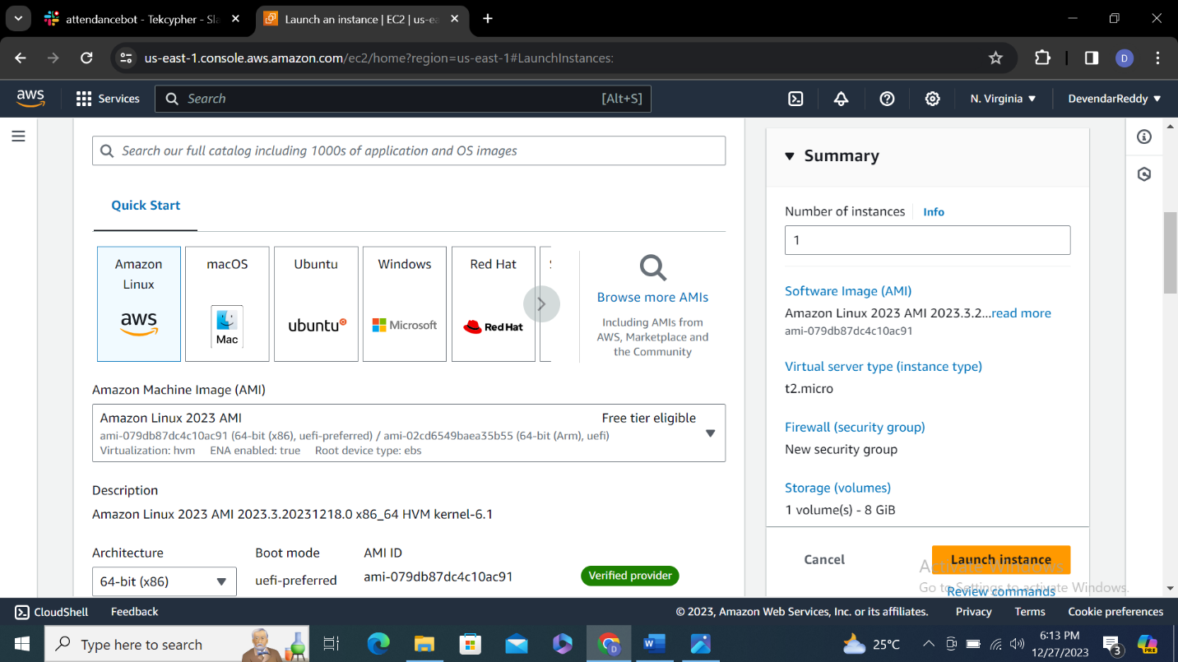

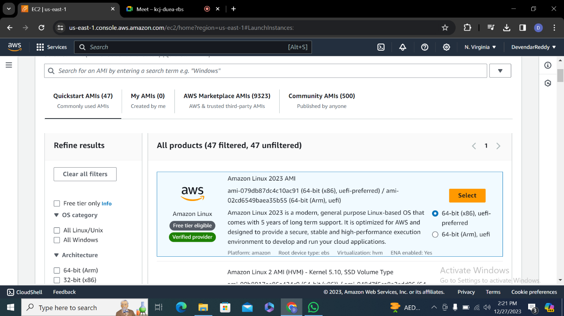

**Step-5 select free instance type(t2 micro)**

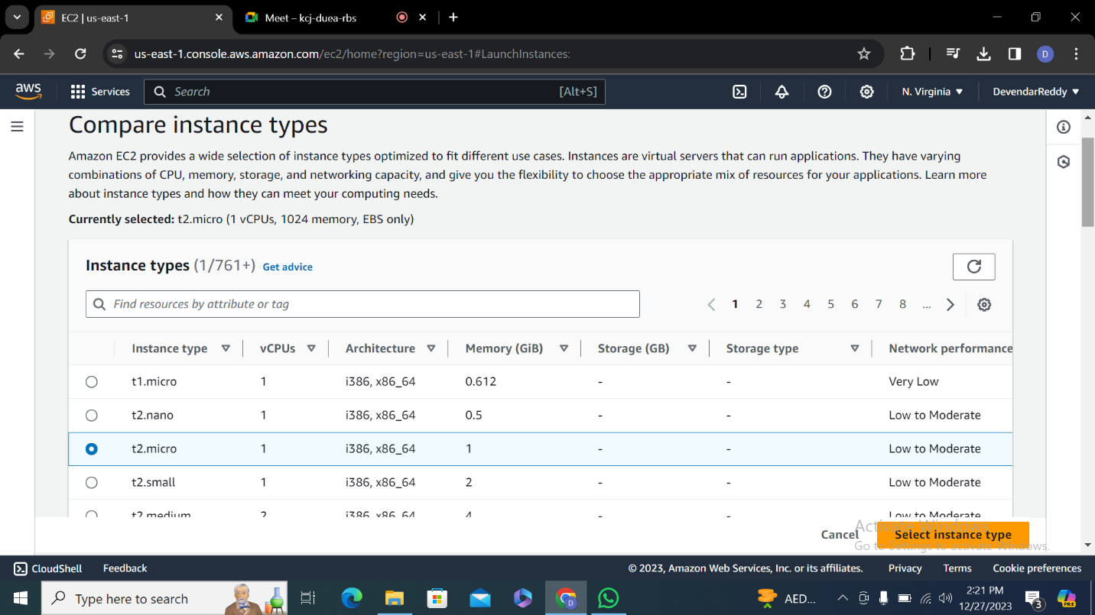

**Step-6-enter key pair select .pem file** 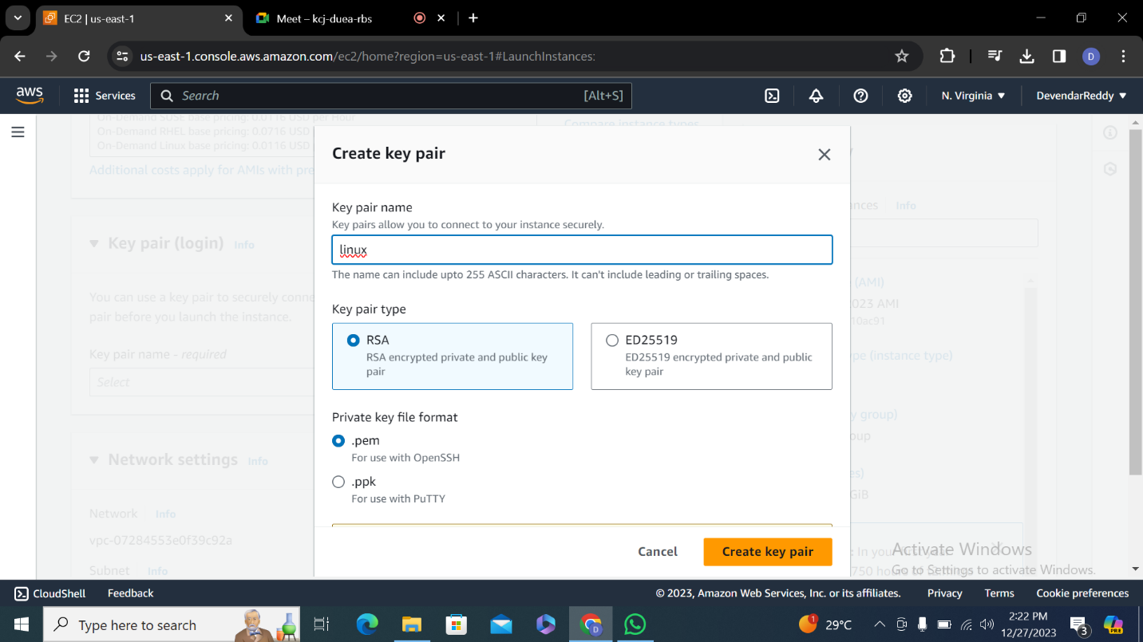

**Step-7 make sure network and configure are default setting**

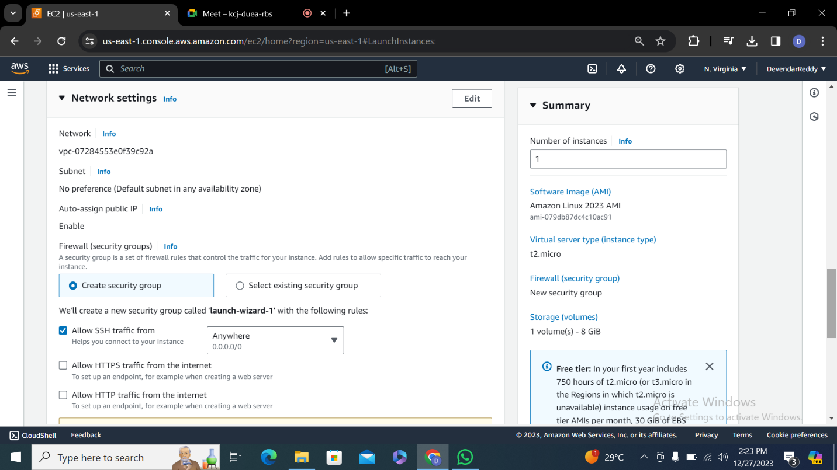

**Click on launch instance**

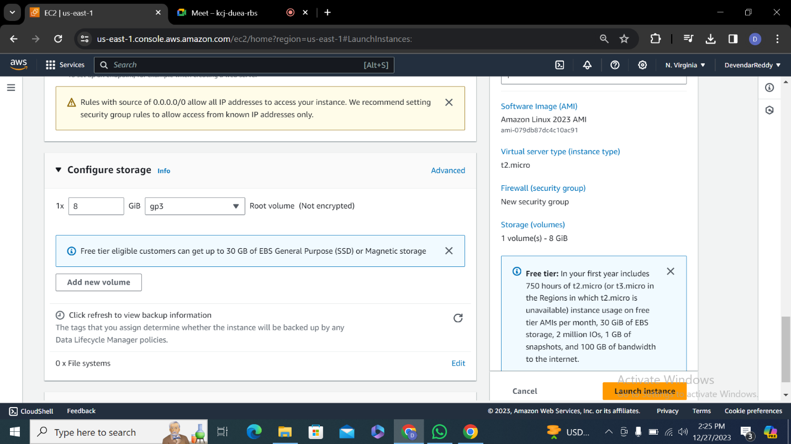

**Step-8 check dash board**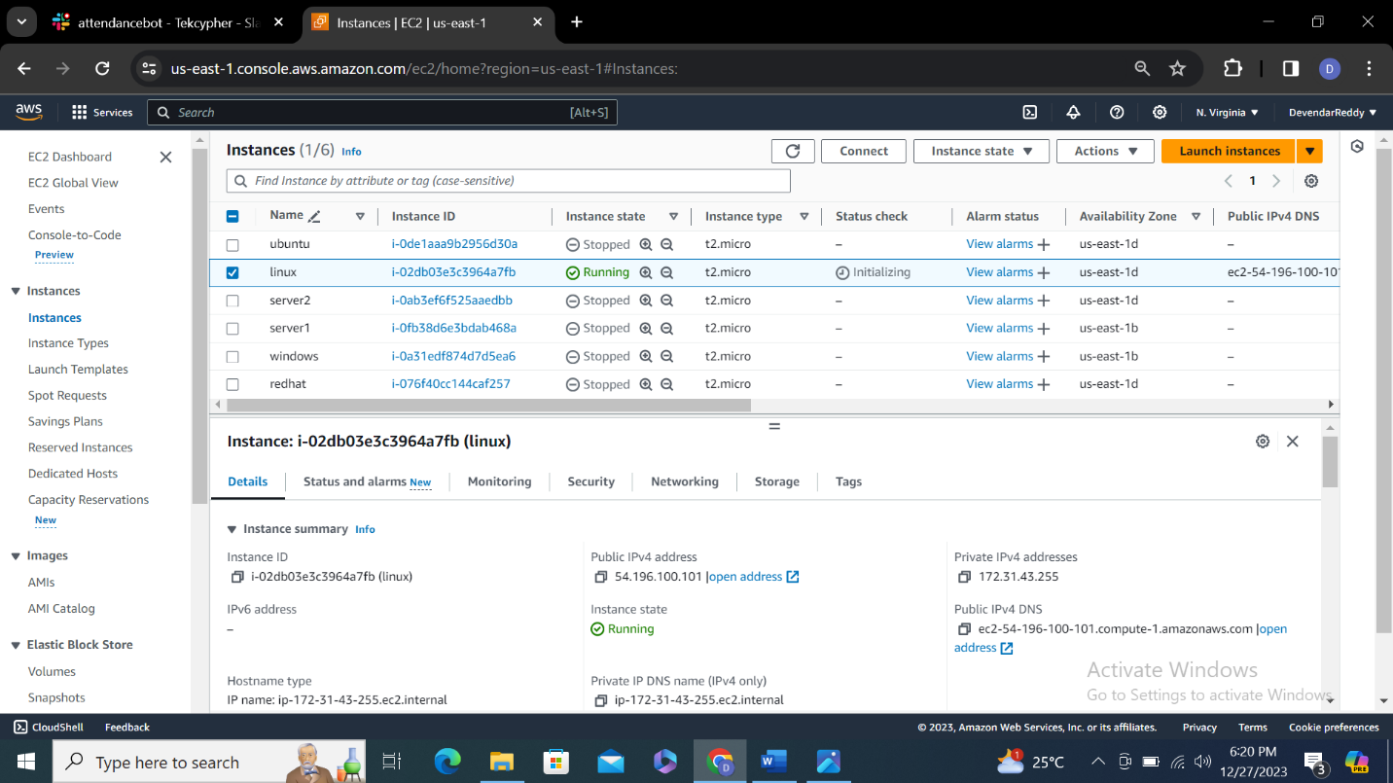

**Step-9 Open Moba Xterm** 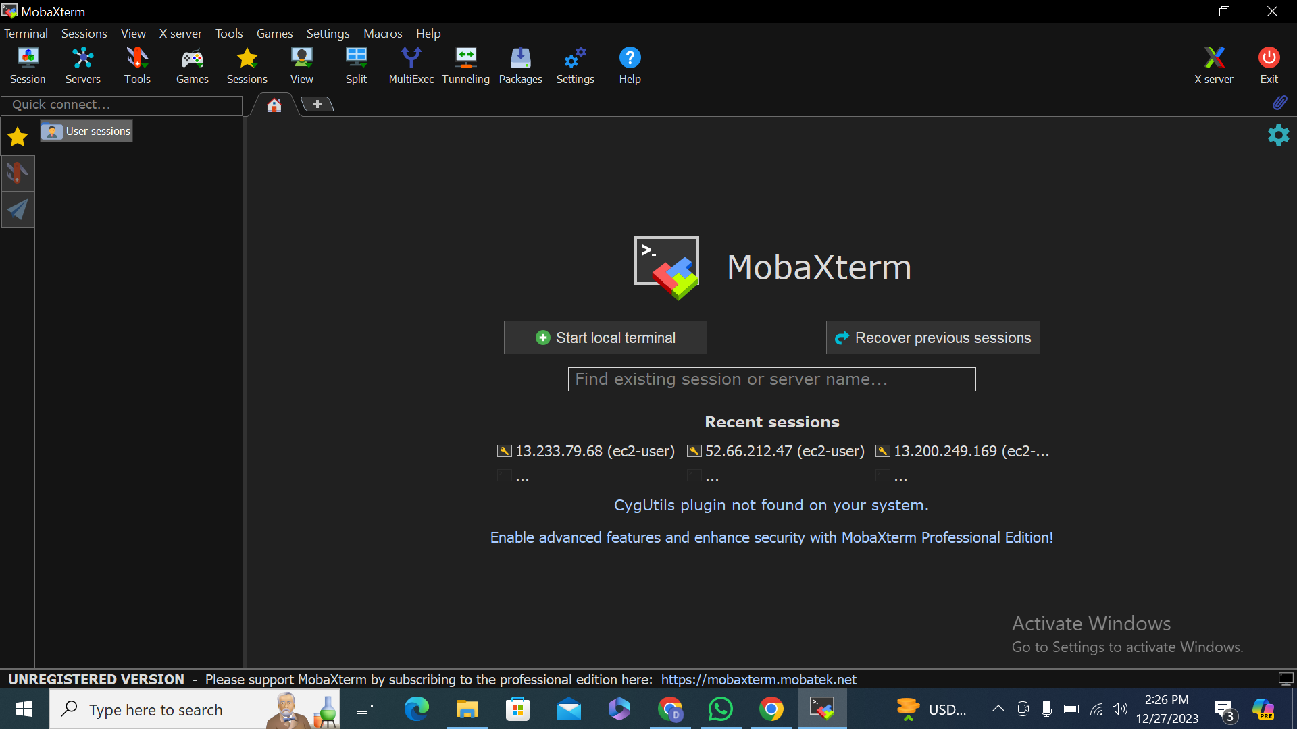

**Step-10 click on session and ssh enter public ip address and specify user name and upload .pem file which we downloaded in key pair**

**Click ok**

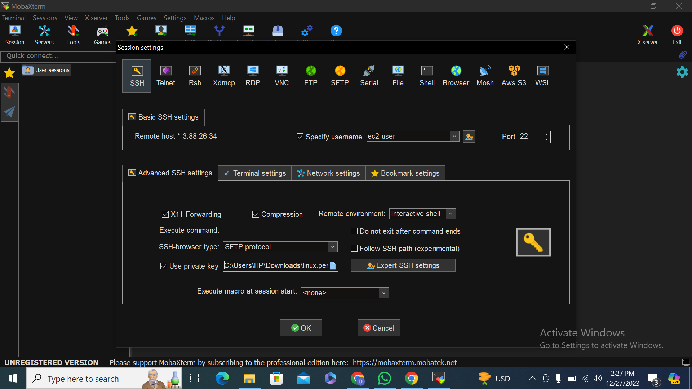

**Step-11 check wheather private key we got in moba xterm and in dash board both are same or not**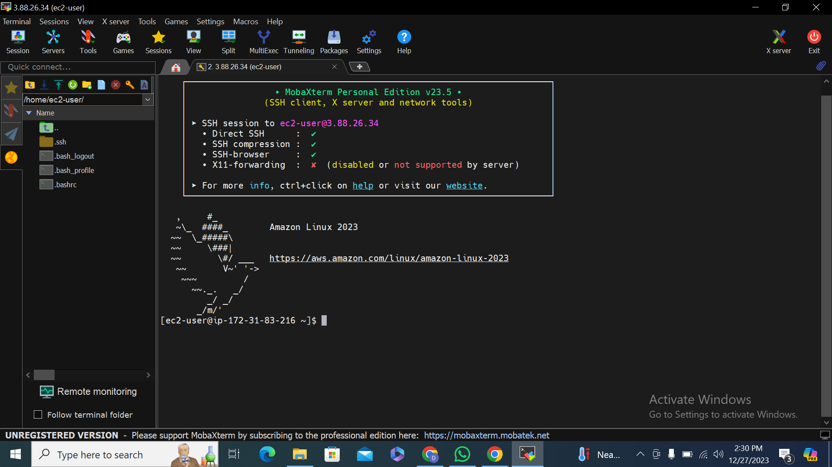

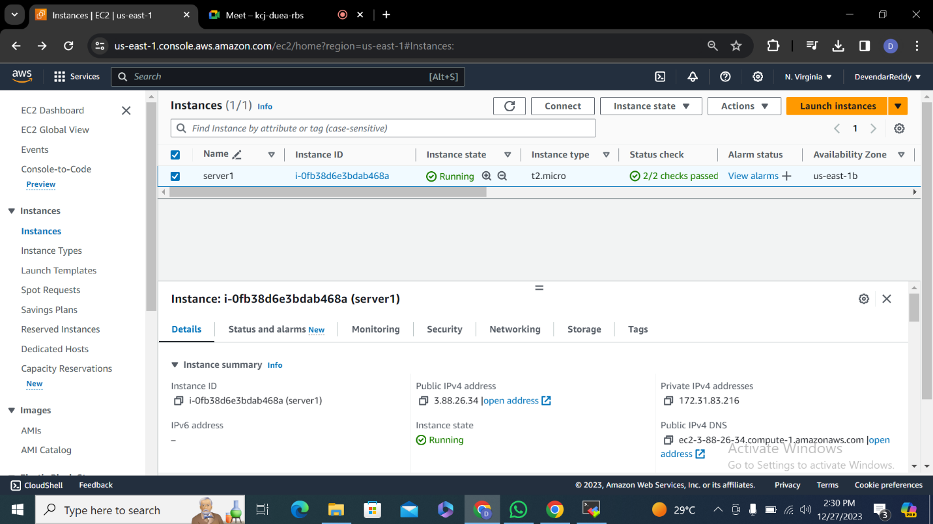

**AMAZON LINUX 2AMI KERNAL (2nd instance )**

**1.**

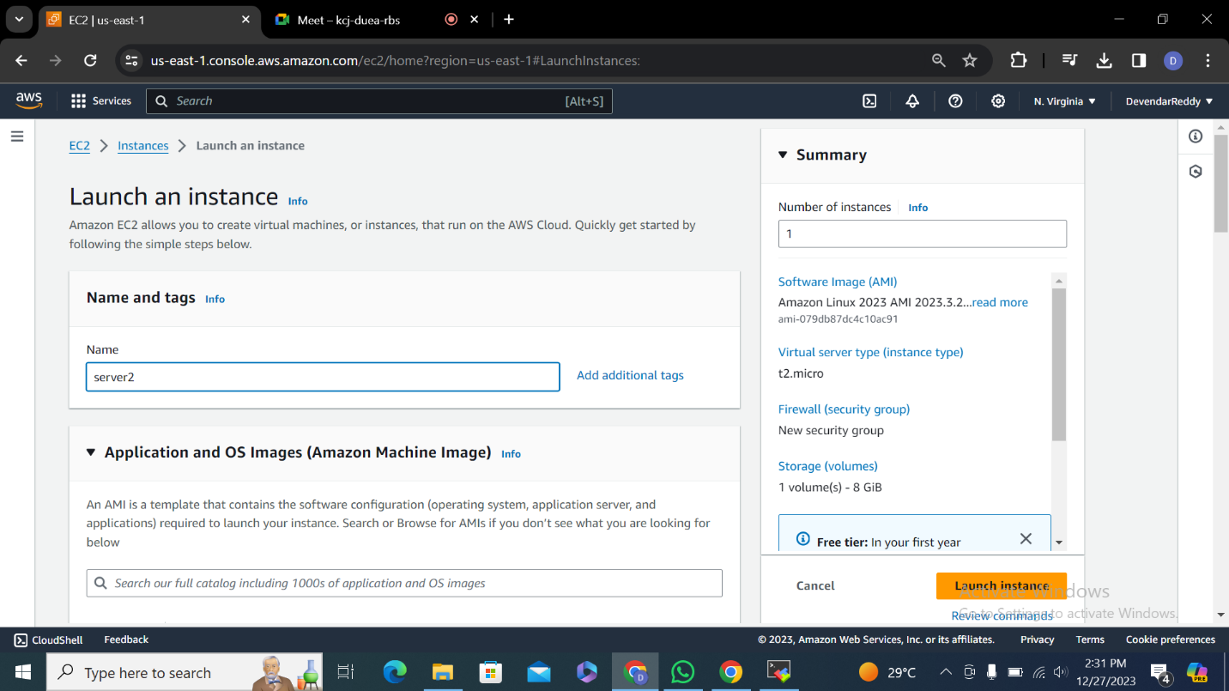

**2.**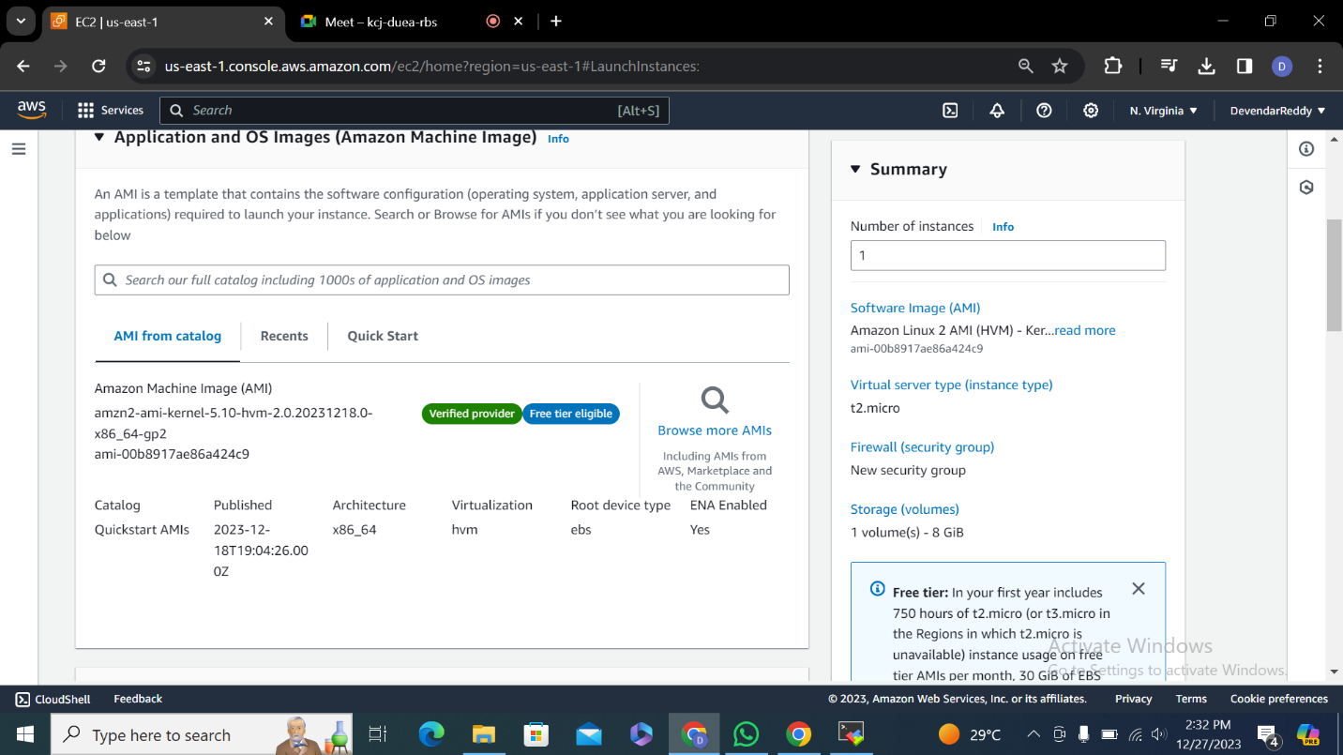

**3.**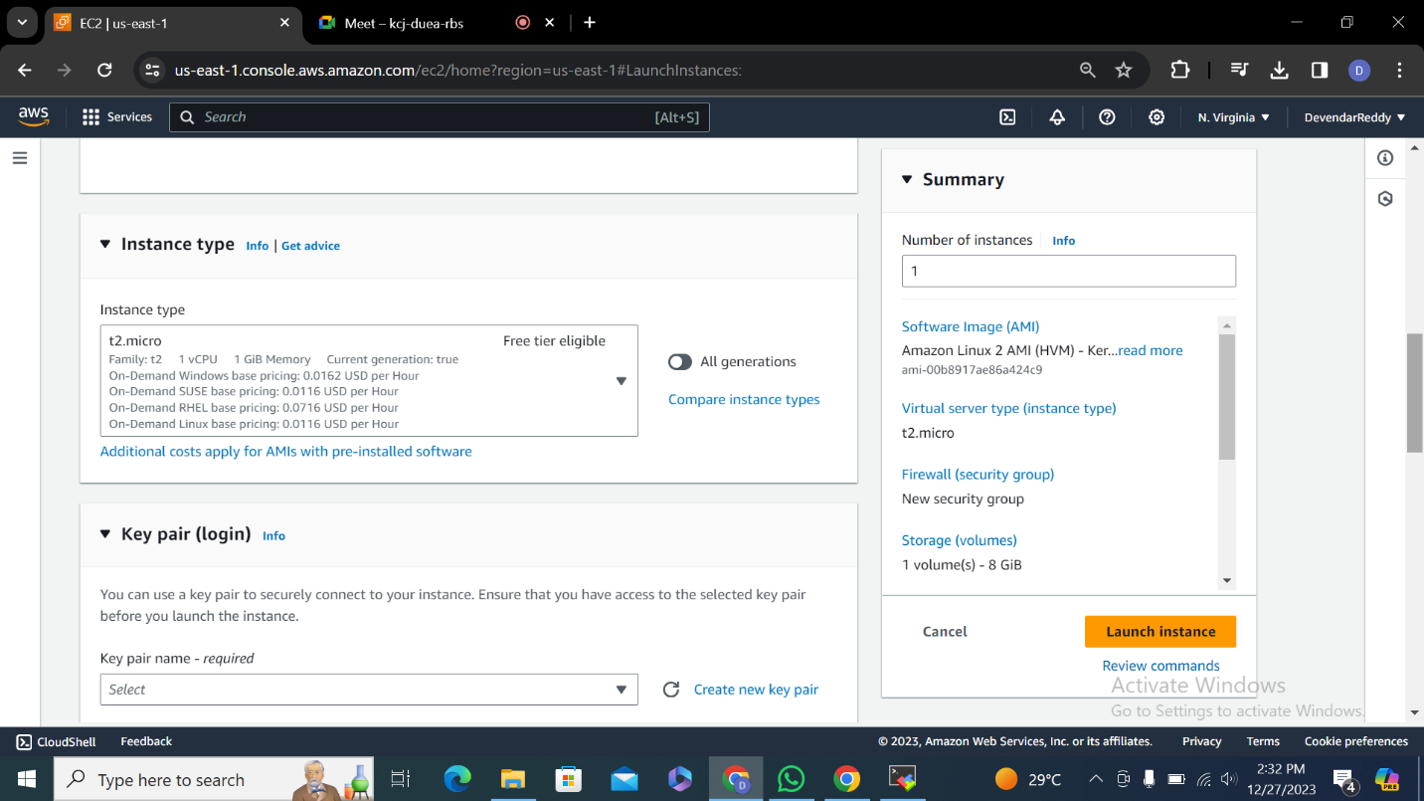

**4.**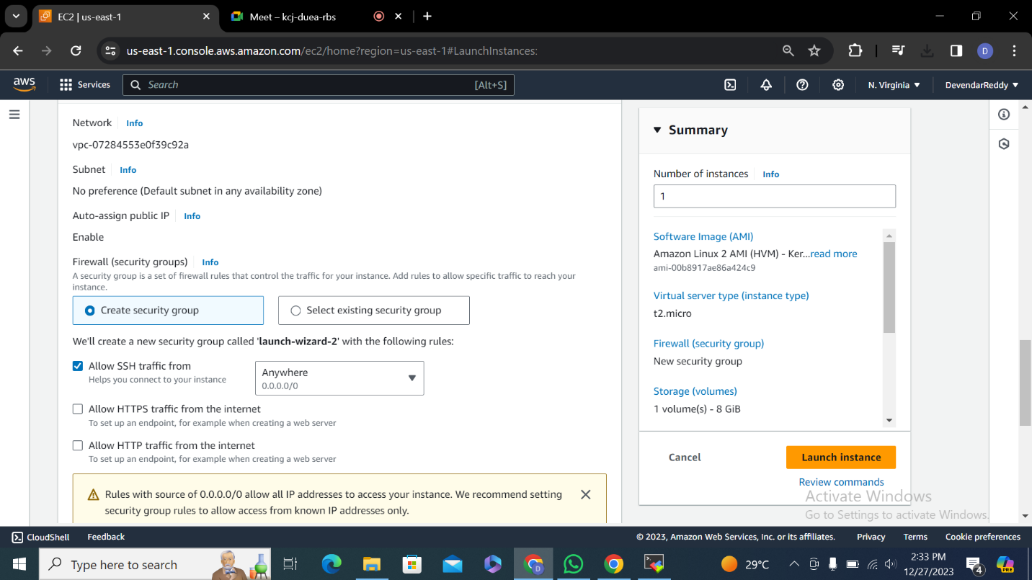

**5. launch instance**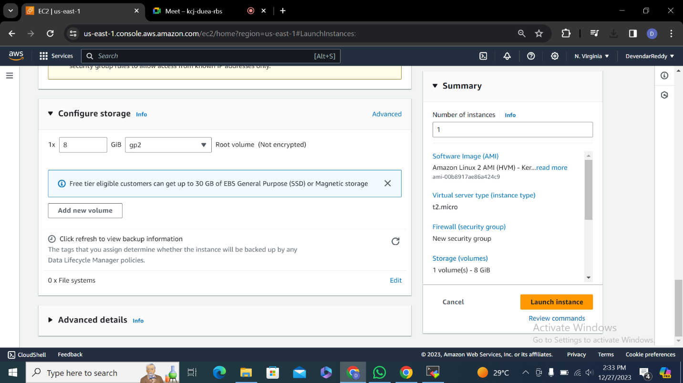

**6.**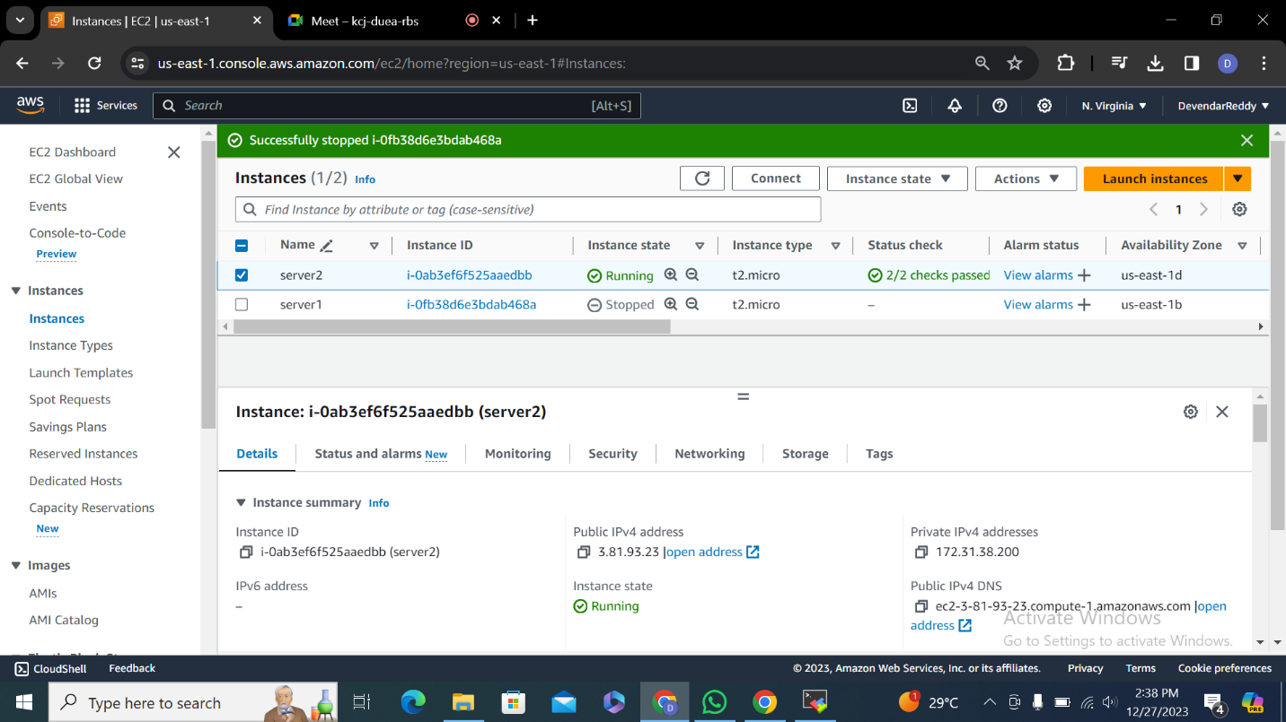

**7.**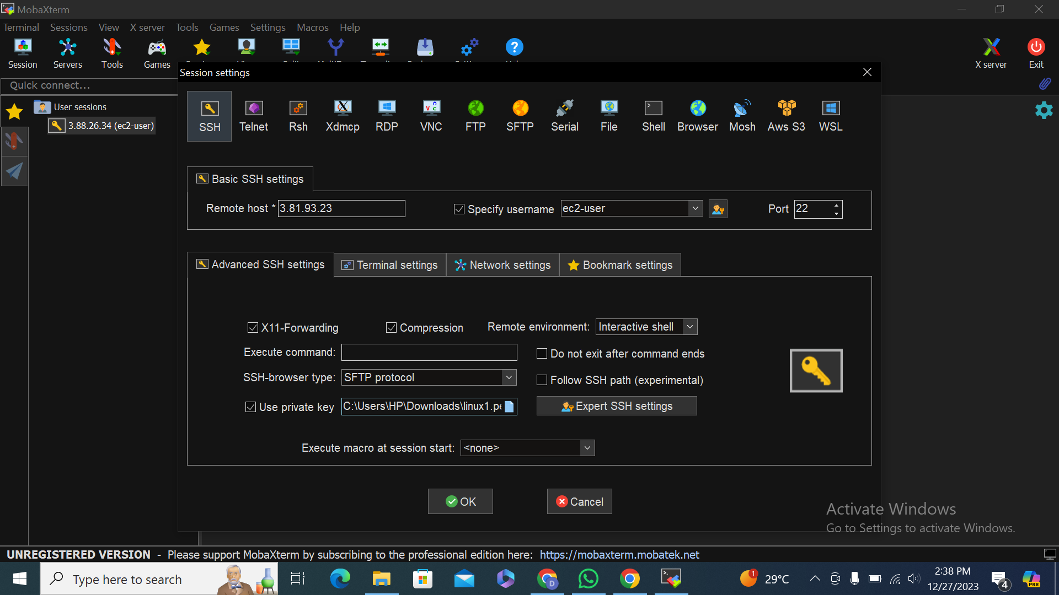

**8.**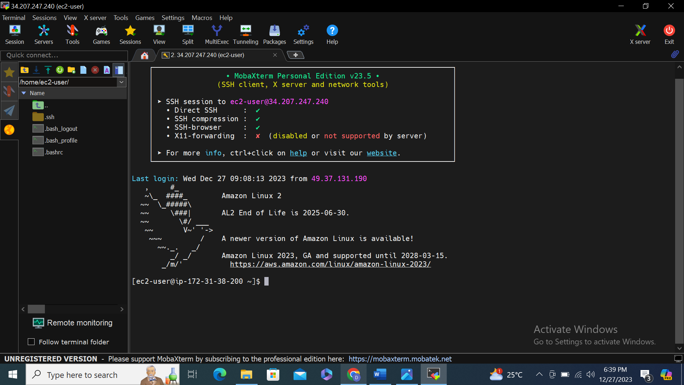

**9.**